Activity: Campus ID Card Screen (React Native with Expo)
Activity Goal
Build a Campus ID Card Screen using SafeAreaView, View, Text, Image, and Flexbox.
The screen should display:
- Student photo
- Student name
- Student ID
- Program name
- Professional card layout

Learning Outcomes
By the end of this activity, students will be able to:
- Create a new screen in an Expo project.
- Use the SafeAreaView component.
- Display text using Text.
- Display images using Image.
- Organize content using View.
- Apply Flexbox for layout and alignment.
- Style a screen using StyleSheet.

Steps
Step 1: Create the Screen
Create a new file: app/(tabs)/index.tsx
Add the following starter code:
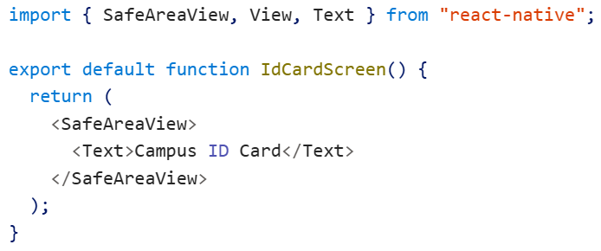
Test the Screen: Run the application and navigate to /id-card
Expected result: Campus ID Card appear on the emulator screen

Step 2: Import Required Components
Update the imports:
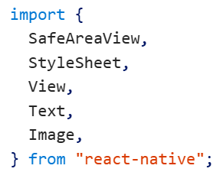
Why?
Component | Purpose
SafeAreaView | Keeps content inside the safe display area
View | Groups UI elements
Text | Displays text
Image | Displays pictures
StyleSheet | Stores styles

Step 3: Build the Card Container
Add a card layout inside the screen.
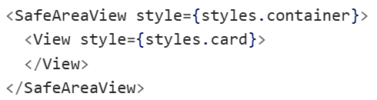
Add Styles
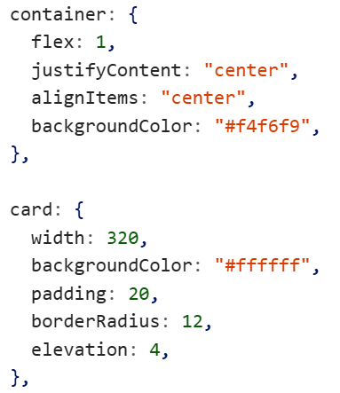
Expected Result: A white card appears centered on the screen.

Step 4: Add a Profile Photo
Inside the card add:
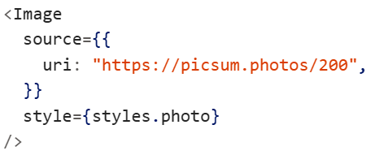
Add Style
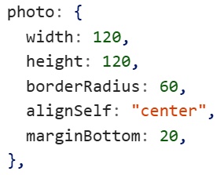
Explanation
- Width = 120
- Height = 120
- Border radius = 60 creates a circle
- Aligns image to center

Step 5: Create the Name and ID Row
Under the image add:
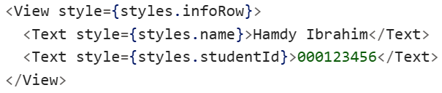
Add Styles
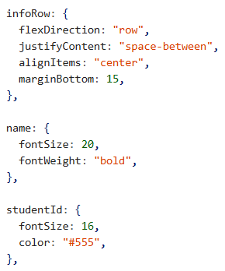

Step 6: Add a Program Badge
Below the Name/ID row add:
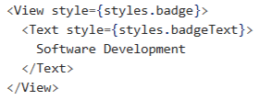
Add Styles
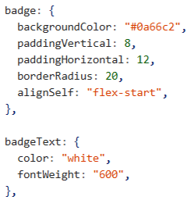

Step 7: Add a Card Header
Above the image add:
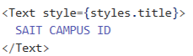
Style
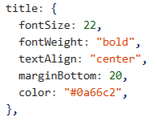
The complete code for ID card can be found in “unit resources/id-card.tsx”
Expected Result
